|  |  |
| --- | --- |
| EXP.NO: 1  DATE: | ACCURACY OF VARIOUS ACTIVATION FUNCTIONS |

**AIM:**

To test the accuracies of various activation functions.

**ALGORITHM:**

* **Import Libraries**: Load TensorFlow, NumPy, and Matplotlib.
* **Load MNIST Data**: Get training and test data from MNIST.
* **Normalize Data**: Scale image pixel values to [0, 1].
* **Build Model**: Create a neural network with Flatten, Dense, Dropout, and Output layers.
* **Compile Model**: Set optimizer, loss function, and evaluation metric.
* **Train Model**: Train the model for 8 epochs.
* **Evaluate Model**: Test the model on unseen data.
* **Print Results**: Show loss and accuracy values.
* **Plot Chart**: Create a bar chart to compare model accuracies.
* **Show Chart**: Display the bar chart.

**PROGRAM:**

import numpy as np

import tensorflow as tf

import matplotlib.pyplot as plt

from tensorflow.keras.models import Sequential

from tensorflow.keras.layers import Dense, Flatten

from tensorflow.keras.datasets import mnist

(x_train, y_train), (x_test, y_test) = mnist.load_data()

x_train, x_test = x_train / 255.0, x_test / 255.0

activations = ['relu', 'sigmoid', 'tanh', 'softmax', 'swish']

accuracy_results = {}

for activation in activations:

model = Sequential([

Flatten(input_shape=(28, 28)),

Dense(128, activation=activation),

Dense(10, activation='softmax')

])

model.compile(optimizer='adam',

loss='sparse_categorical_crossentropy',

metrics=['accuracy'])

history = model.fit(x_train, y_train, epochs=5, validation_data=(x_test, y_test), verbose=0)

accuracy_results[activation] = history.history['val_accuracy']

plt.figure(figsize=(10, 6))

for activation, accuracy in accuracy_results.items():

plt.plot(range(1, 6), accuracy, label=activation)

plt.xlabel('Epochs')

plt.ylabel('Validation Accuracy')

plt.title('Accuracy Comparison of Activation Functions')

plt.legend()

plt.show()

**OUTPUT:**

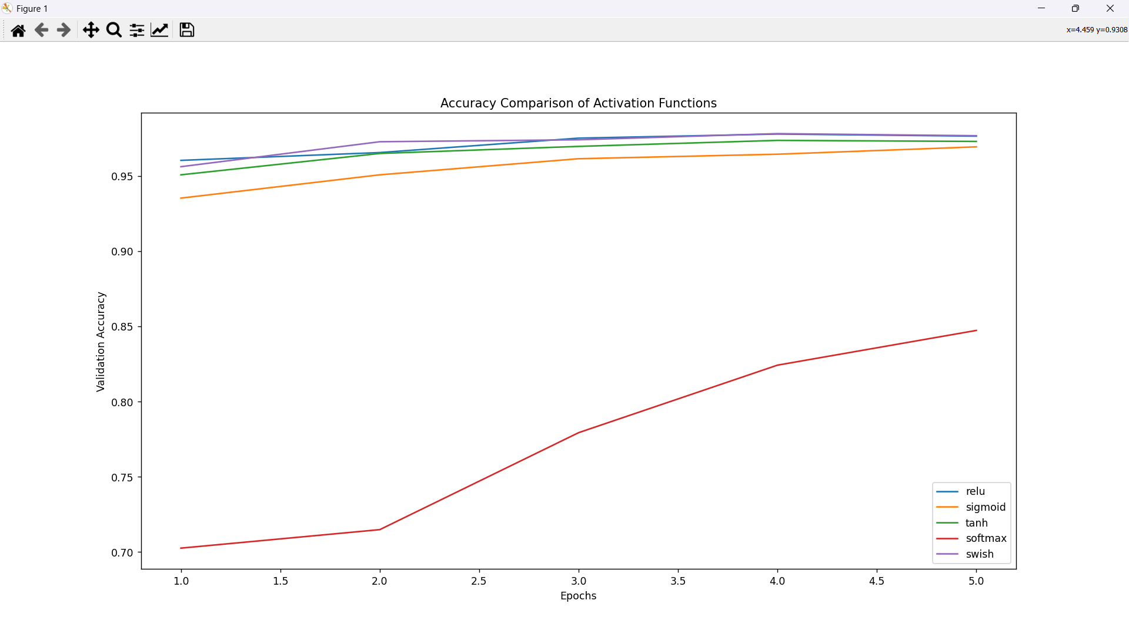

**RESULT:**

Thus the accuracies of various activation functions have been studied successfully.

|  |  |
| --- | --- |
| EXP.NO: 2  DATE: | MLP NEUTRAL NETWORK TO SOLVE THE XOR PROBLEM |

**AIM:**

To solve the given XOR problem using Multilayer Perceptron Neural Network.

**ALGORITHM:**

* Import TensorFlow and NumPy.
* Define XOR inputs and outputs.
* Create an MLP with one hidden (ReLU) and one output (Sigmoid) layer.
* Compile with Adam optimizer and binary crossentropy loss.
* Train for 500 epochs.
* Test predictions on XOR inputs.
* Print results.

**PROGRAM:**

import numpy as np

import tensorflow as tf

from tensorflow import keras

from tensorflow**.**keras**.**models import Sequential

from tensorflow**.**keras**.**layers import Dense

X = np**.**array**([[**0**,** 0**],** **[**0**,** 1**],** **[**1**,** 0**],** **[**1**,** 1**]])**

y = np**.**array**([[**0**],** **[**1**],** **[**1**],** **[**0**]])**

model = Sequential**([**

    Dense**(**4**,** *activation*=**'**relu**',** *input_shape*=**(**2**,)),**

    Dense**(**1**,** *activation*=**'**sigmoid**')**

**])**

model**.**compile**(***optimizer*=**'**adam**',** *loss*=**'**binary_crossentropy**',** *metrics*=**['**accuracy**'])**

model**.**fit**(**X**,** y**,** *epochs*=1000**,** *verbose*=0**)**

predictions = model**.**predict**(**X**)**

*print***("**Predictions:**",** np**.**round**(**predictions**).**flatten**())**

**OUTPUT:**

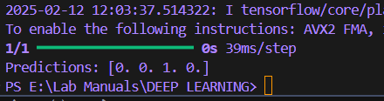

**RESULT:**

Thus, a MLP was built to solve the XOR problem.

|  |  |
| --- | --- |
| EXP.NO: 3  DATE: | ARTIFICIAL NEURAL NETWORK TO RECOGNIZE CHARACTERS AND DIGITS FROM IMAGES |

**AIM:**

To build a Artificial Neural Network to recognize characters and digits from images.

**ALGORITHM:**

* **Import Libraries**: Use Keras and NumPy.
* **Load Data**: Load MNIST dataset (28x28 images).
* **Preprocess Data**: Normalize inputs and one-hot encode outputs.
* **Build Model**:
  + 1. Add Flatten, Dense (120 neurons, ReLU), and Dense (10 neurons, Softmax) layers.
* **Compile**: Use Adam optimizer and categorical crossentropy loss.
* **Train Model**: Train for 10 epochs with validation.
* **Evaluate Model**: Test accuracy on the test set.
* **Predict**: Predict classes for test data and display results.

**PROGRAM:**

import tensorflow as tf

from tensorflow import keras

import numpy as np

import matplotlib**.**pyplot as plt

from PIL import Image**,** ImageOps

import os

mnist = keras**.**datasets**.**mnist

**(**x_train**,** y_train**),** **(**x_test**,** y_test**)** = mnist**.**load_data**()**

**#** Normalize and Reshape

x_train**,** x_test = x_train / 255.0**,** x_test / 255.0

x_train = x_train**.**reshape**(**-1**,** 28**,** 28**,** 1**)**

x_test = x_test**.**reshape**(**-1**,** 28**,** 28**,** 1**)**

**#** Define CNN Model (More Layers for Accuracy)

model = keras**.**Sequential**([**

    keras**.**Input**(***shape*=**(**28**,** 28**,** 1**)),**

    keras**.**layers**.**Conv2D**(**32**,** **(**3**,** 3**),** *activation*=**'**relu**',** *padding*=**'**same**'),**

    keras**.**layers**.**MaxPooling2D**(**2**,** 2**),**

    keras**.**layers**.**Conv2D**(**64**,** **(**3**,** 3**),** *activation*=**'**relu**',** *padding*=**'**same**'),**

    keras**.**layers**.**MaxPooling2D**(**2**,** 2**),**

    keras**.**layers**.**Conv2D**(**128**,** **(**3**,** 3**),** *activation*=**'**relu**',** *padding*=**'**same**'),**

    keras**.**layers**.**MaxPooling2D**(**2**,** 2**),**

    keras**.**layers**.**Flatten**(),**

    keras**.**layers**.**Dense**(**256**,** *activation*=**'**relu**'),**

    keras**.**layers**.**Dense**(**10**,** *activation*=**'**softmax**')**

**])**

**#** Compile and Train (More epochs for accuracy)

model**.**compile**(***optimizer*=**'**adam**',** *loss*=**'**sparse_categorical_crossentropy**',** *metrics*=**['**accuracy**'])**

model**.**fit**(**x_train**,** y_train**,** *epochs*=10**,** *validation_data*=**(**x_test**,** y_test**))**

**#** Evaluate Model

test_loss**,** test_acc = model**.**evaluate**(**x_test**,** y_test**)**

*print***(**f**"**\nTest Accuracy: {test_acc:.4f}**")**

**#** Function to Load and Preprocess Image

def load_and_preprocess_image**(***image_path***):**

    if not os**.**path**.**exists**(***image_path***):**

*print***("**Error: File not found!**")**

        return None

    try**:**

        img = Image**.**open**(***image_path***).**convert**('**L**')**  **#** Convert to grayscale

        img = ImageOps**.**invert**(**img**)**  **#** Invert colors (MNIST has white text, black bg)

        img = img**.**resize**((**28**,** 28**))**  **#** Resize to match MNIST

        img = np**.**array**(**img**,** *dtype*=np**.**float32**)** */* 255.0  **#** Normalize

        img = img**.**reshape**(**1**,** 28**,** 28**,** 1**)**  **#** Reshape for model input

**#** Debug: Show processed image before prediction

        plt**.**imshow**(**img**.**reshape**(**28**,** 28**),** *cmap*=**'**gray**')**

        plt**.**title**("**Processed Image**")**

        plt**.**axis**('**off**')**

        plt**.**show**()**

        return img

    except *Exception* as e**:**

*print***(**f**"**Error loading image: {e}**")**

        return None

**#** Provide Image Path

image_path = r**"**E:\Lab Manuals*\D*EEP LEARNING\image*.*png**"**  **#** Ensure correct path

**#** Load and Predict Image

img = load_and_preprocess_image**(**image_path**)**

if img is not None**:**

    predictions = model**.**predict**(**img**)**

    predicted_label = np**.**argmax**(**predictions**)**

**#** Show Final Prediction

    plt**.**imshow**(**img**.**reshape**(**28**,** 28**),** *cmap*=**'**gray**')**

    plt**.**title**(**f**"**Predicted: {predicted_label}**")**

    plt**.**axis**('**off**')**

    plt**.**show**()**

else**:**

*print***("** Failed to load image.**")**

**OUTPUT:**

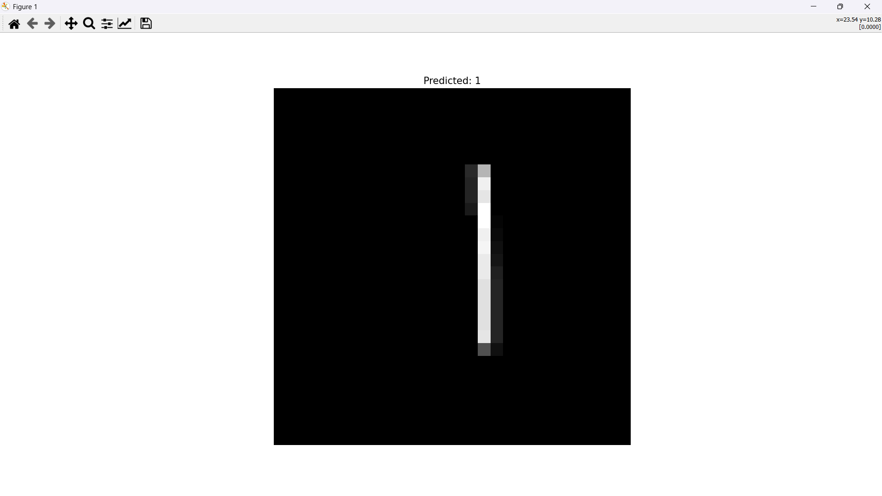

**RESULT:**

Thus, an Artificial Neural Network to recognize characters and digits from images.

|  |  |
| --- | --- |
| EXP.NO: 4  DATE: | PROGRAM USING AUTOENCODERS TO ANALYZE IMAGES FOR IMAGE RECONSTRUCTION TASKS |

**AIM:**

To write a program using autoencoders to analyze images for image reconstruction tasks

**ALGORITHM:**

* **Import Libraries**: Use NumPy, Matplotlib, and Keras modules.
* **Load Dataset**: Load Fashion MNIST data and normalize it to the range [0, 1].
* **Reshape Data**: Reshape the data to include the channel dimension (28, 28, 1).
* **Build Autoencoder**:
  1. **Encoder**: Use Conv2D and MaxPooling2D layers to compress input.
  2. **Decoder**: Use Conv2D and UpSampling2D layers to reconstruct input.
* **Compile Model**: Use Adam optimizer and binary crossentropy loss.
* **Train Model**: Fit the autoencoder on the training data for 5 epochs.
* **Test Reconstruction**: Generate reconstructed images from test data.
* **Visualize Results**: Plot original and reconstructed images side by side.

**PROGRAM:**

from keras**.**datasets import cifar10

import numpy as np

import matplotlib**.**pyplot as plt

from keras**.**models import Model

from keras**.**layers import Input**,** Conv2D**,** MaxPooling2D**,** UpSampling2D

**(**X_train**,** _**),** **(**X_test**,** _**)** = cifar10**.**load_data**()**

X_train = X_train**.**astype**('**float32**')** / 255.0

X_test = X_test**.**astype**('**float32**')** / 255.0

X_train = X_train**.**reshape**((***len***(**X_train**),** 32**,** 32**,** 3**))**

X_test = X_test**.**reshape**((***len***(**X_test**),** 32**,** 32**,** 3**))**

input_img = Input**(***shape*=**(**32**,** 32**,** 3**))**

x = Conv2D**(**32**,** **(**3**,** 3**),** *activation*=**'**relu**',** *padding*=**'**same**')(**input_img**)**

x = MaxPooling2D**((**2**,** 2**),** *padding*=**'**same**')(**x**)**

x = Conv2D**(**16**,** **(**3**,** 3**),** *activation*=**'**relu**',** *padding*=**'**same**')(**x**)**

encoded = MaxPooling2D**((**2**,** 2**),** *padding*=**'**same**')(**x**)**

x = Conv2D**(**16**,** **(**3**,** 3**),** *activation*=**'**relu**',** *padding*=**'**same**')(**encoded**)**

x = UpSampling2D**((**2**,** 2**))(**x**)**

x = Conv2D**(**32**,** **(**3**,** 3**),** *activation*=**'**relu**',** *padding*=**'**same**')(**x**)**

x = UpSampling2D**((**2**,** 2**))(**x**)**

decoded = Conv2D**(**3**,** **(**3**,** 3**),** *activation*=**'**sigmoid**',** *padding*=**'**same**')(**x**)**

autoencoder = Model**(**input_img**,** decoded**)**

autoencoder**.**compile**(***optimizer*=**'**adam**',** *loss*=**'**binary_crossentropy**')**

autoencoder**.**fit**(**X_train**,** X_train**,** *epochs*=10**,** *batch_size*=256**,** *shuffle*=True**,** *validation_data*=**(**X_test**,** X_test**))**

decoded_imgs = autoencoder**.**predict**(**X_test**)**

n = 10

plt**.**figure**(***figsize*=**(**20**,** 4**))**

for i in *range***(**n**):**

    ax = plt**.**subplot**(**2**,** n**,** i + 1**)**

    plt**.**imshow**(**X_test**[**i**])**

    ax**.**get_xaxis**().**set_visible**(**False**)**

    ax**.**get_yaxis**().**set_visible**(**False**)**

    ax = plt**.**subplot**(**2**,** n**,** i + 1 + n**)**

    plt**.**imshow**(**decoded_imgs**[**i**])**

    ax**.**get_xaxis**().**set_visible**(**False**)**

    ax**.**get_yaxis**().**set_visible**(**False**)**

plt**.**show**()**

**OUTPUT:**

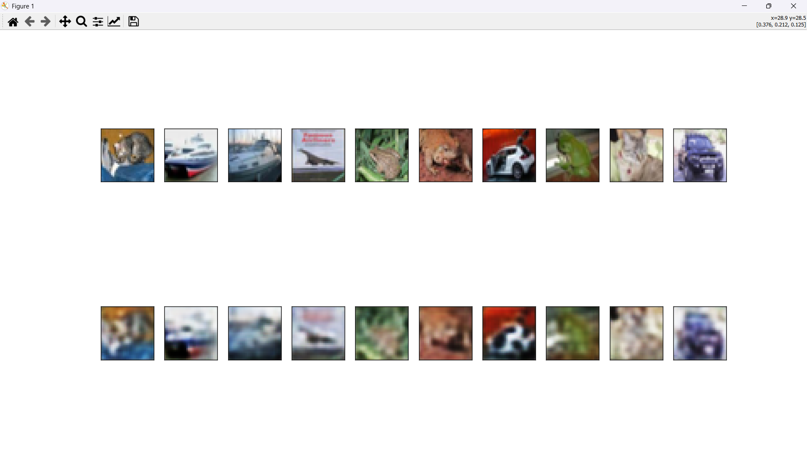

**RESULT:**

Thus, a program using autoencoders to analyze images for image reconstruction tasks was build successfully.

|  |  |
| --- | --- |
| EXP.NO: 5  DATE: | CONVOLUTIONAL NEURAL NETWORK (CNN) FOR SPEECH RECOGNITION |

**AIM:**

To build Convolutional Neural Network for Speech Recognition task.

**ALGORITHM:**

* **Import Libraries**: Use TensorFlow and TensorFlow Datasets.
* **Load Dataset**: Load the "Speech Commands" dataset and split it into train and test sets.
* **Convert to NumPy**: Convert the dataset to NumPy format for easier manipulation.
* **Build Model**:
  1. Add Conv2D layers with ReLU activation.
  2. Add MaxPooling2D layers for down-sampling.
  3. Flatten the output and add Dense layers for classification.
* **Compile Model**: Use Adam optimizer and categorical crossentropy loss.
* **Train Model**: Train the model for 10 epochs on the training data.
* **Evaluate Model**: Evaluate the model's performance on test data and print accuracy.
* **Predict Classes**: Use the model to predict classes for test data and display them.

**PROGRAM:**

import tensorflow as tf

import numpy as np

from sklearn**.**model_selection import train_test_split

from tensorflow**.**keras**.**utils import to_categorical

def generate_dummy_data**(***num_samples*=1000**,** *input_length*=16000**,** *num_classes*=10**):**

    X = np**.**random**.**rand**(***num_samples***,** *input_length***,** 1**)**

    y = np**.**random**.**randint**(**0**,** *num_classes***,** *num_samples***)**

    y = to_categorical**(**y**,** *num_classes*=*num_classes***)**

    return X**,** y

def build_cnn_model**(***input_shape***,** *num_classes***):**

    model = tf**.**keras**.**Sequential**([**

        tf**.**keras**.**layers**.**InputLayer**(***input_shape*=*input_shape***),**

        tf**.**keras**.**layers**.**Conv1D**(**32**,** *kernel_size*=3**,** *activation*=**'**relu**'),**

        tf**.**keras**.**layers**.**MaxPooling1D**(***pool_size*=2**),**

        tf**.**keras**.**layers**.**BatchNormalization**(),**

        tf**.**keras**.**layers**.**Conv1D**(**64**,** *kernel_size*=3**,** *activation*=**'**relu**'),**

        tf**.**keras**.**layers**.**MaxPooling1D**(***pool_size*=2**),**

        tf**.**keras**.**layers**.**BatchNormalization**(),**

        tf**.**keras**.**layers**.**Flatten**(),**

        tf**.**keras**.**layers**.**Dense**(**128**,** *activation*=**'**relu**'),**

        tf**.**keras**.**layers**.**Dropout**(**0.5**),**

        tf**.**keras**.**layers**.**Dense**(***num_classes***,** *activation*=**'**softmax**')**

**])**

    return model

num_samples = 1000

input_length = 16000

num_classes = 10

X**,** y = generate_dummy_data**(**num_samples**,** input_length**,** num_classes**)**

X_train**,** X_test**,** y_train**,** y_test = train_test_split**(**X**,** y**,** *test_size*=0.2**,** *random_state*=42**)**

input_shape = **(**input_length**,** 1**)**

model = build_cnn_model**(***input_shape*=input_shape**,** *num_classes*=num_classes**)**

model**.**compile**(***optimizer*=**'**adam**',** *loss*=**'**categorical_crossentropy**',** *metrics*=**['**accuracy**'])**

epochs = 10

batch_size = 32

*print***("**Training the model...**")**

history = model**.**fit**(**X_train**,** y_train**,** *validation_split*=0.2**,** *epochs*=epochs**,** *batch_size*=batch_size**)**

*print***("**Evaluating the model...**")**

test_loss**,** test_accuracy = model**.**evaluate**(**X_test**,** y_test**,** *verbose*=2**)**

*print***(**f**"**Test Accuracy: {test_accuracy * 100:.2f}%**")**

*print***("**Making predictions on test data...**")**

predictions = model**.**predict**(**X_test**)**

predicted_classes = np**.**argmax**(**predictions**,** *axis*=1**)**

*print***("**First 10 Predictions:**")**

*print***(**predicted_classes**[:**10**])**

**OUTPUT:**

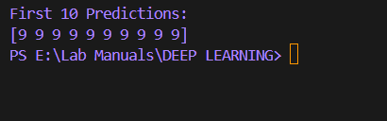

**RESULT:**

Thus, a Convolutional Neural Network for speech recognition was build successfully.